**Pont redresseur**



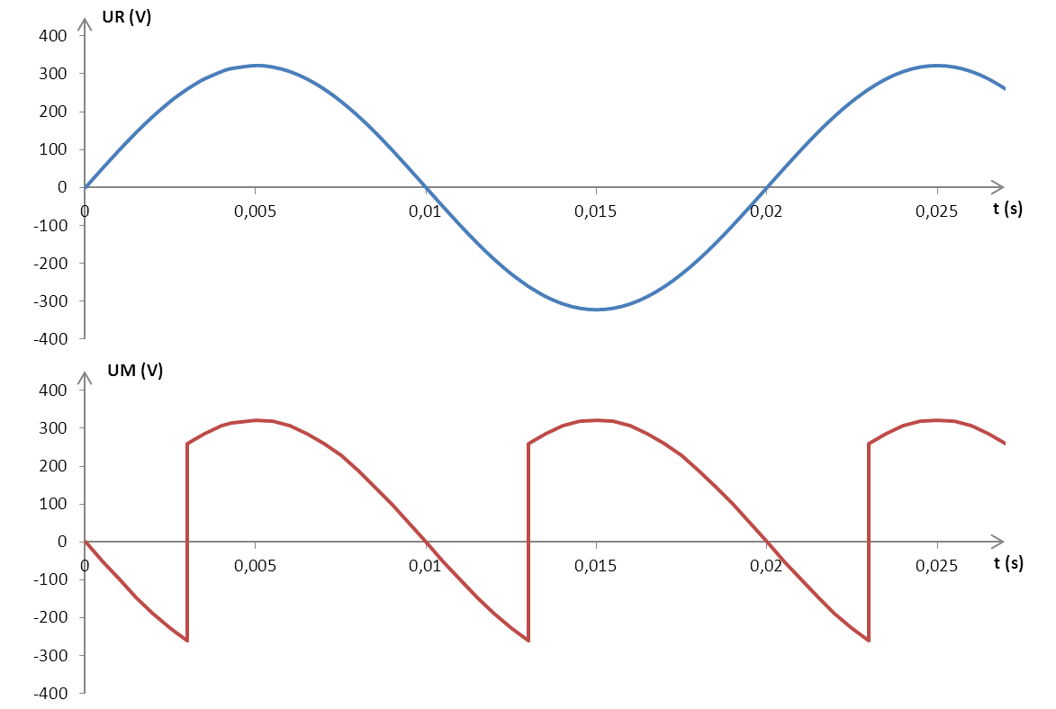

|  |  |
| --- | --- |
| Th1 |  |
| Th2 |  |
| Th3 |  |
| Th4 |  |

**document réponse 3**